Round 2: Determining the Arsenals’ layout
You need now to select a proper location within the city of Springfield and determine the layout of the armory. Thomas Dawes helped design the original layout of the armory and will advise you.
In August 1778, the Continental Congress has authorized a payment to the Commonwealth of Massachusetts for the construction of a powder magazine, elaboratory, and barracks in Springfield. As the appointed overseer, it is your responsibility to determine the means, resources, and final layout of the new arsenal.
Col. Thomas Dawes.
Chief architect of the Armory


“The timber & joist cannot be got until the coming fall & winter. If the Timber could be got the sap up, the worms would soon take it and the buildings in a little time molder away. The demand for boards is now so great from the workmen already there, that it is with some difficulty they get supplied.” -Col. Dawes

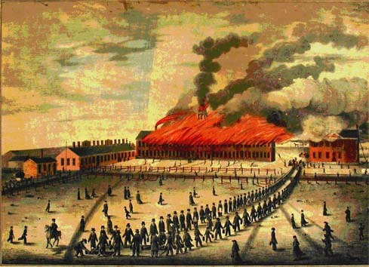
In this dramatic contemporary picture, looking from where the Museum now is and across the Green toward present-day Federal Street, an early 1824 Armory fire is shown consuming the administrative building and stocking shops. The sparks from the forges where iron was shaped and welded, contained in the Forging Shop to the left with the row of narrow chimneys, were most often the source of the periodic building fires at the Armory.
Springfield Armory NHS, US NPS

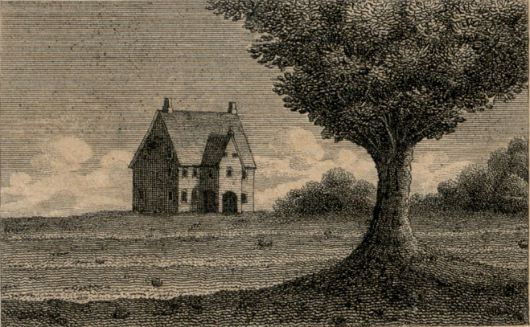
Choice #1 – Immediate Rental for Quick Operations
In late 1777, rent the barn behind the Hitchcock House at Main and Emery Street from Ebenezer Stebbins. This provides an instant solution for storing arms, repairing equipment, and assembling cartridges while the war effort is pressing. The arrangement buys time to secure permanent land for the arsenal but relies on a makeshift facility in the middle of town, with limited space and modest security.

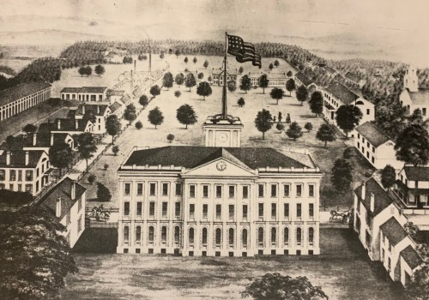
Choice #2 – Purpose-Built Complex on the Training Ground
Purchase Springfield’s militia training field and develop a planned armory complex at what will become Armory Square. Construct a powder magazine, barracks, and workshop around the central green, ensuring a clear separation between explosive storage and work areas. This centralized site allows for efficient operations and future expansion, but it requires significant upfront investment and construction time before full operations can begin.

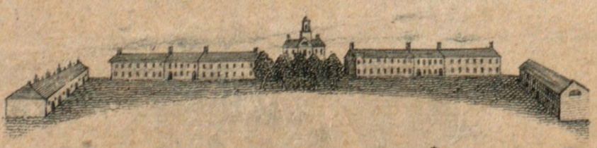
Choice #3 – Single Magazine with Attached Workshop
Acquire a parcel of land on the ridge above Springfield and erect one large, combined powder magazine and workshop. This design minimizes construction time and costs by housing all munitions, tools, and work under one roof. However, the lack of separation between explosive storage and active labor poses a serious risk — a single spark or accident could destroy the facility, halt production, and endanger workers and nearby residents.

Round 2: Determining Armory Construction
Choice #1 – Immediate Rental for Quick Operations
Pros | Cons

Choice #2 – Purpose-Built Complex on the Training Ground
Pros | Cons

Choice #3 – Single Magazine with Attached Workshop
Pros | Cons
Final Decision:
Current Budget | $
Budget change: | $
New Total Budget | $

Round 2: Results
Outcome for Choice #1 – Immediate Rental for Quick Operations
You’re operational within days, providing immediate support to the Continental Army. Repairs and cartridge production begin at once, boosting short-term supply. However, the barn’s cramped quarters limit production capacity, and its location in the middle of town raises security concerns. By the following year, you’re forced to find a larger, safer site, spending additional funds on relocation and construction.
Add $5,000 addition to your staffing budget.

Outcome for Choice #2 – Purpose-Built Complex on the Training Ground
Construction delays mean production won’t start for several months, slowing the flow of munitions to the front in the short term. Once completed, however, the complex operates efficiently and safely, with ample space for future expansion. The separation between magazine, barracks, and workshop prevents accidents, and the site becomes a long-term anchor for arms manufacture in Springfield.
$0 , this decision neither helps nor hurts the Armory’s budget

Outcome for Choice #3 – Single Magazine with Attached Workshop
You begin operations quickly, and centralized production makes the arsenal efficient at first. But the shared roof over explosive powder and active work is a disaster waiting to happen. In 1779, a spark from a tool ignites loose powder, setting off an explosion that destroys the building, kills workers, and halts production for months. Replacement costs and lost time severely weaken Springfield’s role in supplying the army.
-$10,000 from your staffing budget

